ASSIGNMENT 2 – CO2
ARTIFICIAL INTELLIGENCE – CSA1714

Introduction
This assignment studies informed search, online search, game-tree algorithms, constraint propagation and optimisation. Each task follows the required evidence sequence: prediction, design, source code, test input, expected behaviour, actual output, performance measurements and interpretation. The supplied Python files produce the raw CSV measurements and text outputs.
Reproducibility note: the programs use deterministic test cases except for the explicitly seeded random restarts in Task 6. Execution-time values depend on the computer and Python environment. Operation counts are the main evidence.

Task 1 – Greedy Best-First and A* Under Different Map Conditions

Prediction before experiment
Uniform-Cost Search (UCS) expands nodes in increasing path-cost order and guarantees a least-cost path when step costs are non-negative. Greedy Best-First Search uses only the heuristic, so it may reach a goal quickly but can be misled by obstacles or dead ends. A* combines path cost and heuristic and is expected to find an optimal path with an admissible heuristic. The three maps are open, cluttered and dead-end layouts.

Heuristic and admissibility
The heuristic is Manhattan distance: h(r,c)=|r−r_goal|+|c−c_goal|. The grid permits only horizontal and vertical moves of cost 1. If obstacles are removed, Manhattan distance is exactly the shortest relaxed-problem distance. Obstacles can only preserve or increase the real path length, so h never overestimates the true remaining cost. Therefore it is admissible.

Algorithm and test design
Each cell is a state. The four adjacent cells are successors. UCS priority is g(n), Greedy priority is h(n), and A* priority is g(n)+h(n). The three maps in Task-1/task1.py are the test inputs. The program records expanded/generated nodes, maximum frontier size, path cost and time.
Expected behaviour: UCS and A* should return an optimal path. Greedy may expand fewer nodes on a suitable map but has no optimality guarantee. Obstacle layout can change the relative work.

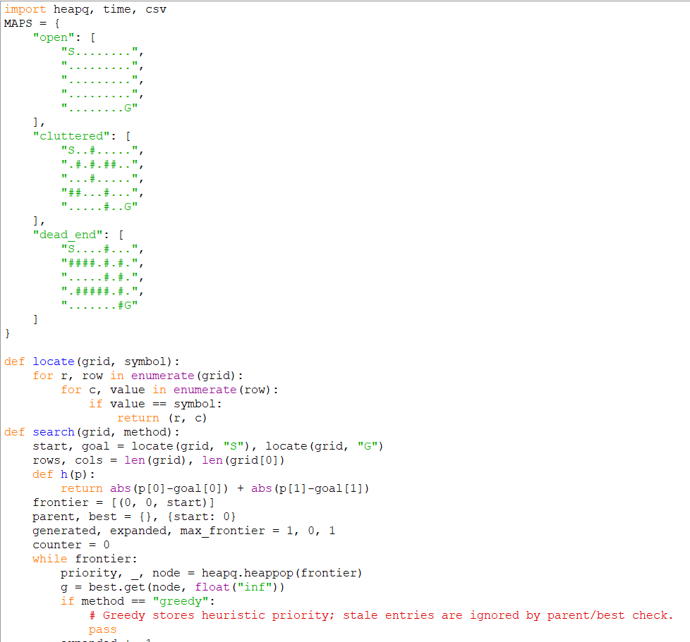
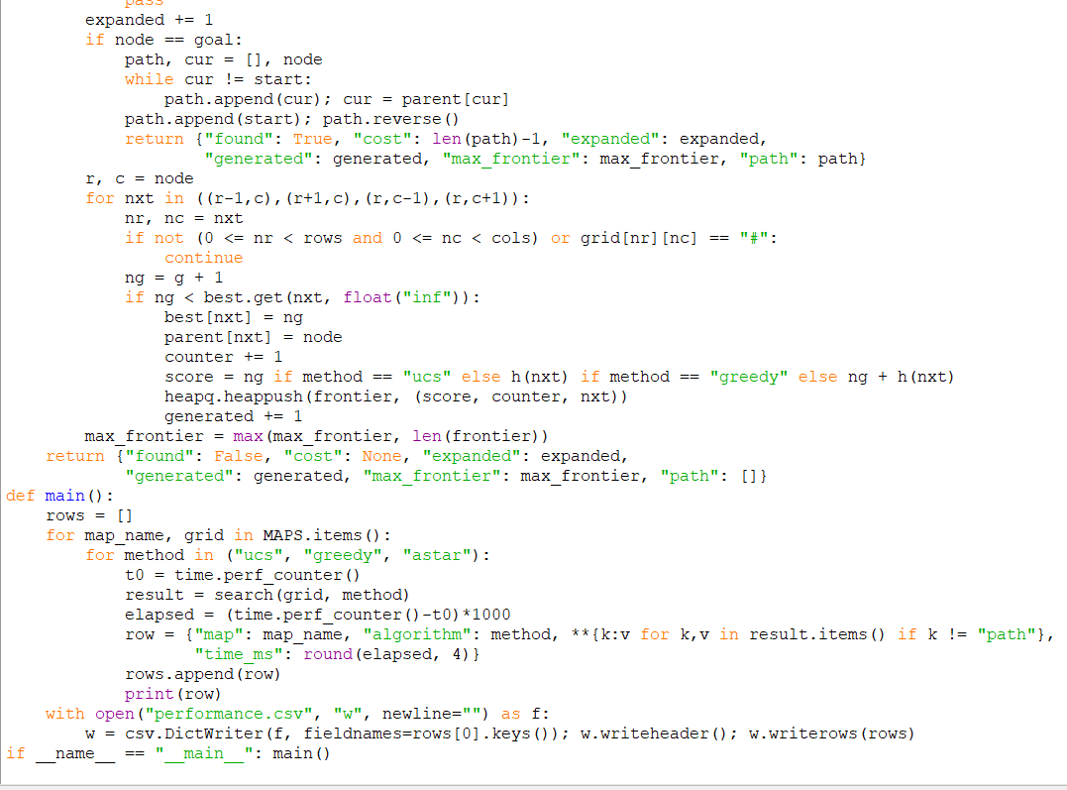

Actual output and performance
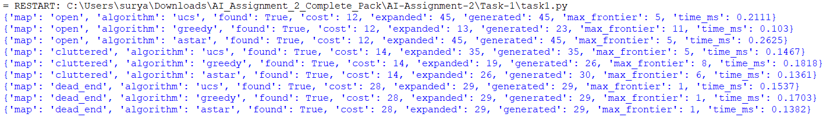
map | algorithm | found | cost | expanded | generated | max_frontier | time_ms
open | ucs | True | 12 | 45 | 45 | 5 | 0.0826
open | greedy | True | 12 | 13 | 23 | 11 | 0.0321
open | astar | True | 12 | 45 | 45 | 5 | 0.086
cluttered | ucs | True | 14 | 35 | 35 | 5 | 0.0433
cluttered | greedy | True | 14 | 19 | 26 | 8 | 0.032
cluttered | astar | True | 14 | 26 | 30 | 6 | 0.037
dead_end | ucs | True | 28 | 29 | 29 | 1 | 0.0331
dead_end | greedy | True | 28 | 29 | 29 | 1 | 0.0359
dead_end | astar | True | 28 | 29 | 29 | 1 | 0.0365
Table 1. Search performance on the three campus maps.
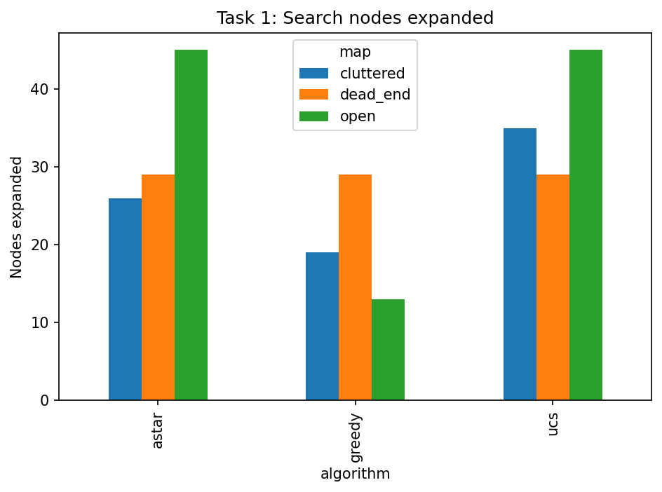
Figure 1. Nodes expanded by each search algorithm.
Interpretation: compare path cost as well as node counts. UCS and A* provide optimality guarantees under the stated costs and heuristic conditions. Greedy is a speed-oriented choice only when a non-optimal route is acceptable. Since most shuttle trips are on open roads, A* is the recommended general choice: Manhattan distance directs search toward the destination while retaining optimality. If memory or implementation simplicity dominates and the map is tiny, UCS remains a reliable alternative.

Task 2 – When Is an Online Search Agent Appropriate?

Prediction before experiment
An online depth-first agent learns the environment while moving. A nearby target in a simple corridor should require few moves. Dead ends and unreachable targets can force exploration and backtracking. Revisited-cell count should increase when the agent must return through known cells. A competitive ratio is defined as travelled moves divided by the shortest path cost known to an offline agent.

Algorithm and test design
The agent uses a stack and senses adjacent cells as it reaches each location. It explores an unvisited open neighbour; when none remains, it backtracks. The simulator has access to the map only to provide local sensor readings and to calculate the offline shortest-path baseline. Three cases are tested: near target, farther target and unreachable target.

Expected behaviour
The near and far cases should find the target. The unreachable case should explore the reachable component and report failure. Its competitive ratio is undefined because no finite start-to-goal optimal path exists.
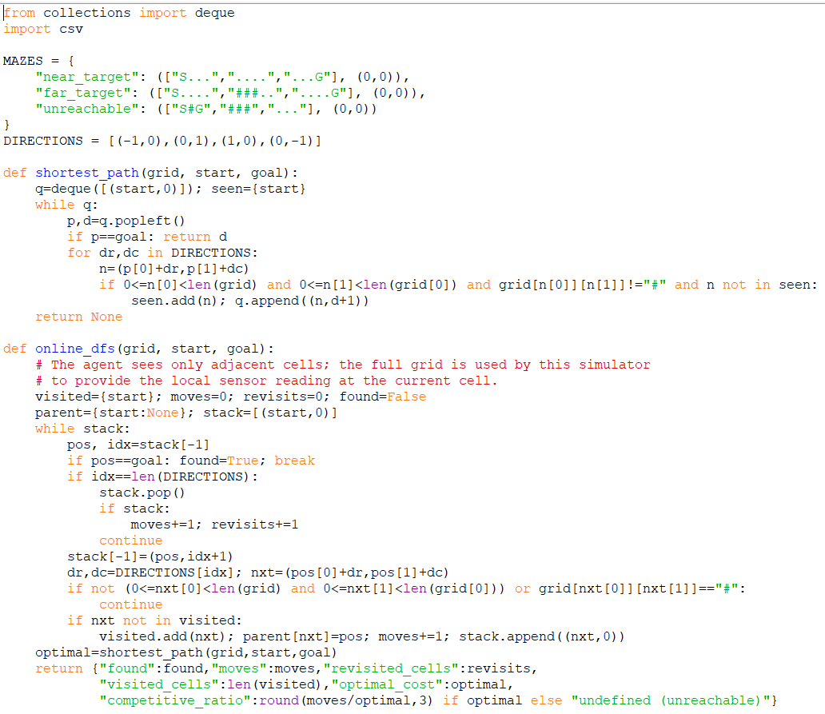

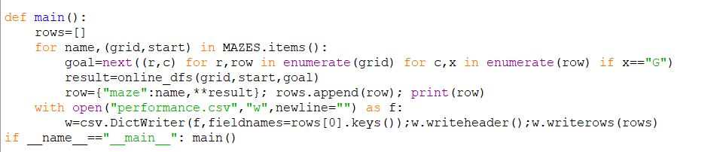

Actual output and performance
maze | found | moves | revisited_cells | visited_cells | optimal_cost | competitive_ratio
near_target | True | 5 | 0 | 6 | 5.0 | 1.0
far_target | True | 6 | 0 | 7 | 6.0 | 1.0
unreachable | False | 0 | 0 | 1 | nan | undefined (unreachable)
Table 2. Online DFS moves, revisits and competitive ratio.
Interpretation and operating boundary: online search is reasonable when the map is initially unknown, local sensing is available, exploration risk is acceptable and the target is expected to be reachable. It is less suitable for large environments with many dead ends, strict energy limits or time-critical missions. With 20 rovers in fixed facilities whose maps remain unchanged for months, learning the map once and reusing it makes a purely online DFS less attractive for repeated missions. A stored map and planned routes can reduce repeated exploration; online sensing can still handle unexpected changes.

Task 3 – Engineer the Behaviour of Alpha-Beta Pruning

Prediction before experiment
Minimax examines the complete tree. Alpha-beta returns the same minimax value but may stop exploring branches that cannot affect the final decision. Good move ordering should create earlier cutoffs. Poor ordering and equal leaf values may reduce the benefit. A full binary tree of depth 3 is used with three leaf arrangements.

Algorithm and test design
The root is MAX, the next level is MIN, and levels alternate. Minimax evaluates every leaf. Alpha-beta carries alpha (best value for MAX) and beta (best value for MIN). A cutoff occurs when alpha is greater than or equal to beta. The three leaf sequences are in Task-3/task3.py.
Expected behaviour: both algorithms return the same value. Minimax visits every node; alpha-beta visits no more nodes and should record cutoffs where bounds make a branch irrelevant.
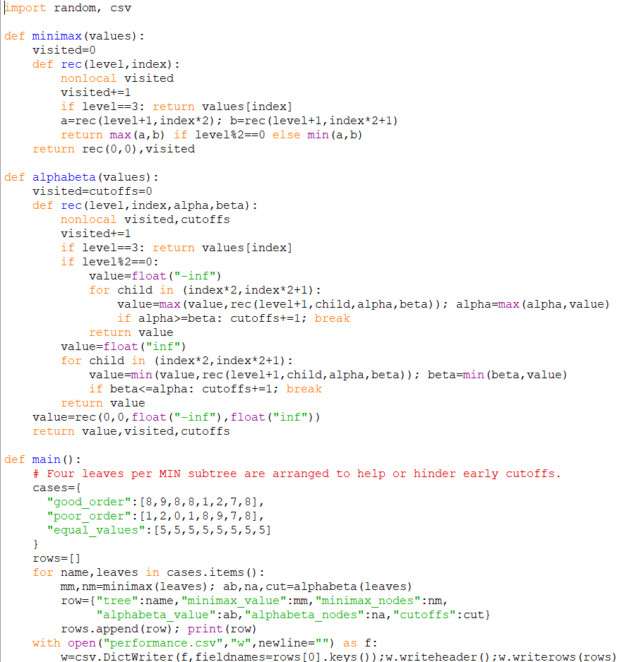

Actual output and performance

tree | minimax_value | minimax_nodes | alphabeta_value | alphabeta_nodes | cutoffs
good_order | 8 | 15 | 8 | 12 | 1
poor_order | 8 | 15 | 8 | 15 | 0
equal_values | 5 | 15 | 5 | 11 | 2
Table 3. Minimax and alpha-beta node counts.
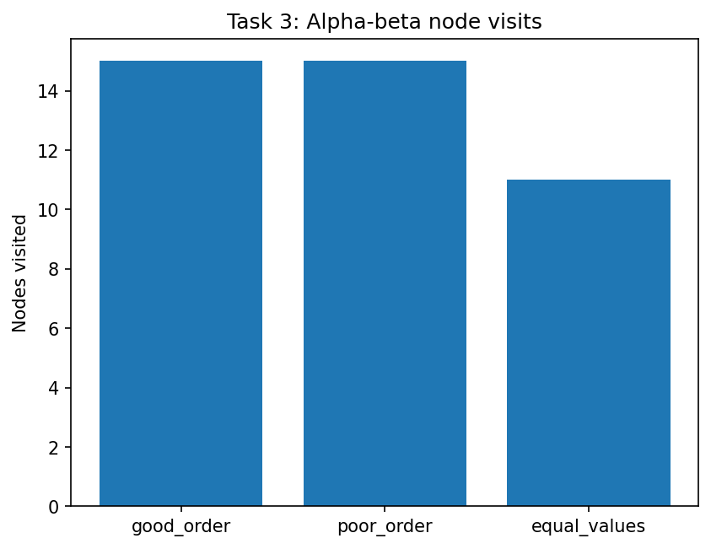
Figure 2. Alpha-beta node visits for the designed trees.
Interpretation: pruning depends not only on branching factor and depth but also on the order in which children are examined. A good move order can reveal a strong bound early. A poor order delays the bound and causes more nodes to be visited. Equal values can also affect when the cutoff condition is reached.

Task 4 – Minimax and the Cost of Examining Every Possibility

Prediction and mathematical derivation
For branching factor b and lookahead depth d, the number of nodes in a complete tree is N=1+b+b²+…+b^d=(b^(d+1)−1)/(b−1), for b≠1. The number of terminal evaluations is b^d. With b=3, each extra depth multiplies the number of leaf evaluations by 3.
At the depth limit, the evaluation function assigns a numeric score to each leaf position. MAX selects the largest child score and MIN selects the smallest.

Test design and expected behaviour
The program uses a deterministic three-branch game tree at depths 2, 3, 4 and 5. The predicted node counts are the geometric-series values, and the evaluation-call count should equal 3^d.
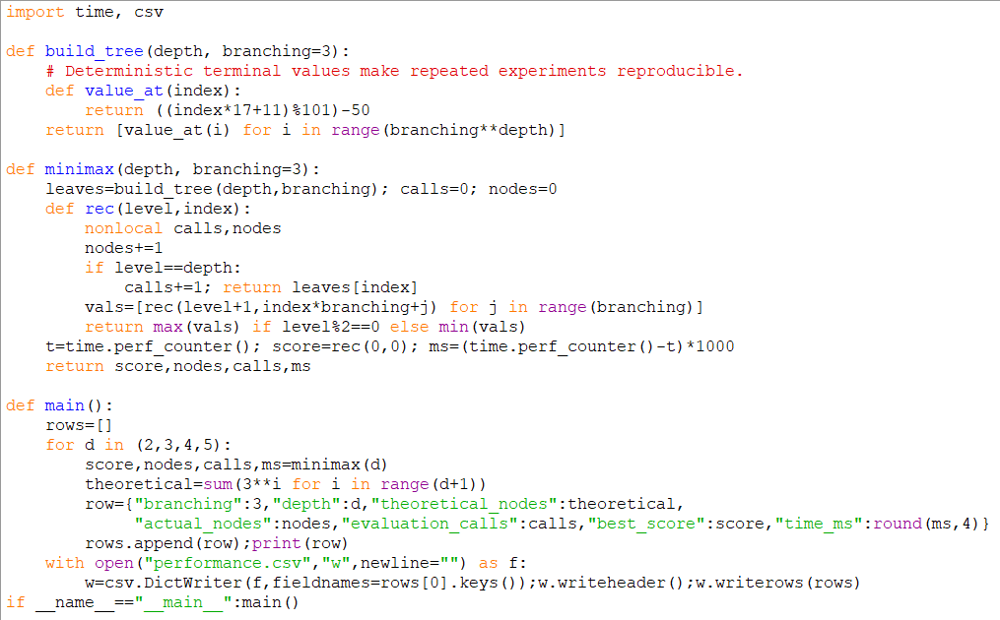

Actual output and performance

branching | depth | theoretical_nodes | actual_nodes | evaluation_calls | best_score | time_ms
3 | 2 | 13 | 13 | 9 | 12 | 0.0071
3 | 3 | 40 | 40 | 27 | -2 | 0.0072
3 | 4 | 121 | 121 | 81 | 12 | 0.0174
3 | 5 | 364 | 364 | 243 | 25 | 0.0502
Table 4. Theoretical and measured minimax growth.
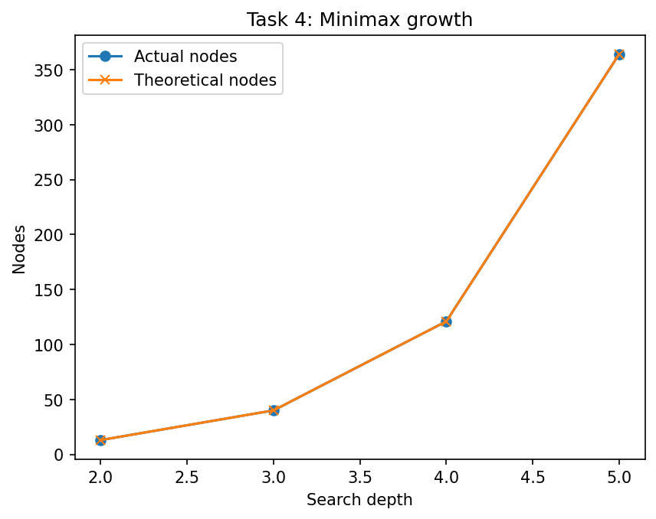
Figure 3. Theoretical and actual minimax node growth.
Interpretation and scalability: the measured node count should match the complete-tree formula because this implementation deliberately visits every node. For this experiment, an acceptable response-time target can be set to 1 second. The largest practical depth depends on hardware, branching factor and evaluation cost; growth is exponential in depth. The main inefficiency is evaluating every possible continuation, including branches that cannot influence the final choice. A redesigned strategy should reduce examined nodes while preserving decision quality, for example by ordering promising moves and pruning bounded branches.

Task 5 – Derive a Constraint-Propagation Algorithm

Principle and derived procedure
Each exam is a variable and each available time slot is a domain value. Exams that share students are neighbours and cannot use the same slot. A value is removed from a variable when a neighbouring variable has no compatible value. The implementation uses the AC-3 queue procedure: examine an ordered pair (Xi,Xj), revise Xi, and if Xi changes, re-examine arcs from its other neighbours. An empty domain means failure.

Pseudocode
1. Put every directed constraint arc in a queue. 2. Remove one arc (Xi,Xj). 3. For each value in domain(Xi), check whether at least one compatible value exists in domain(Xj). 4. Remove unsupported values. 5. If Xi becomes empty, report failure. 6. If Xi changed, add arcs (Xk,Xi) for neighbours Xk other than Xj. 7. Continue until the queue is empty. 8. Combine propagation with backtracking by selecting an unassigned exam, trying a slot, and propagating again.

Prediction and test design
Propagation should reduce domains before branching and can detect contradictions early. The challenge instance is a four-variable cycle. Both propagation and plain backtracking are measured using nodes, backtracks, constraint checks and domain wipe-outs. The first chain case includes a singleton domain to demonstrate propagation from a fixed exam.
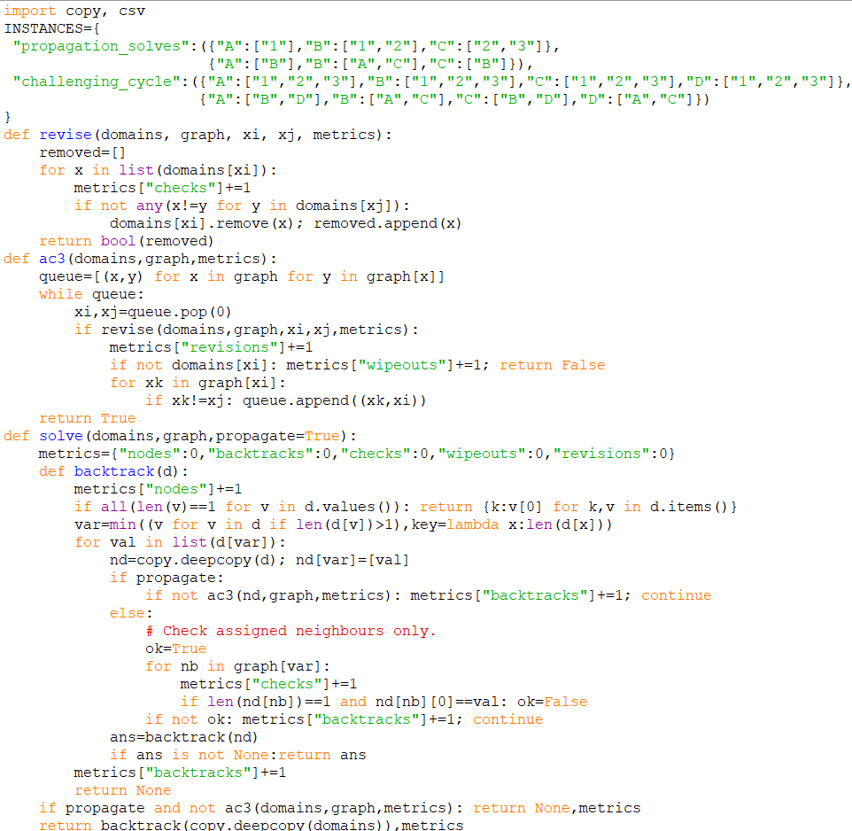

Actual output and performance
instance | propagation | solution | nodes | backtracks | checks | wipeouts | revisions
propagation_solves | False | {'A': '1', 'B': '2', 'C': '3'} | 3 | 2 | 6 | 0 | 0
propagation_solves | True | {'A': '1', 'B': '2', 'C': '3'} | 1 | 0 | 7 | 0 | 2
challenging_cycle | False | {'A': '1', 'B': '2', 'C': '1', 'D': '2'} | 5 | 2 | 12 | 0 | 0
challenging_cycle | True | {'A': '1', 'B': '2', 'C': '1', 'D': '2'} | 5 | 0 | 81 | 0 | 3
Table 5. Constraint-solving measurements.
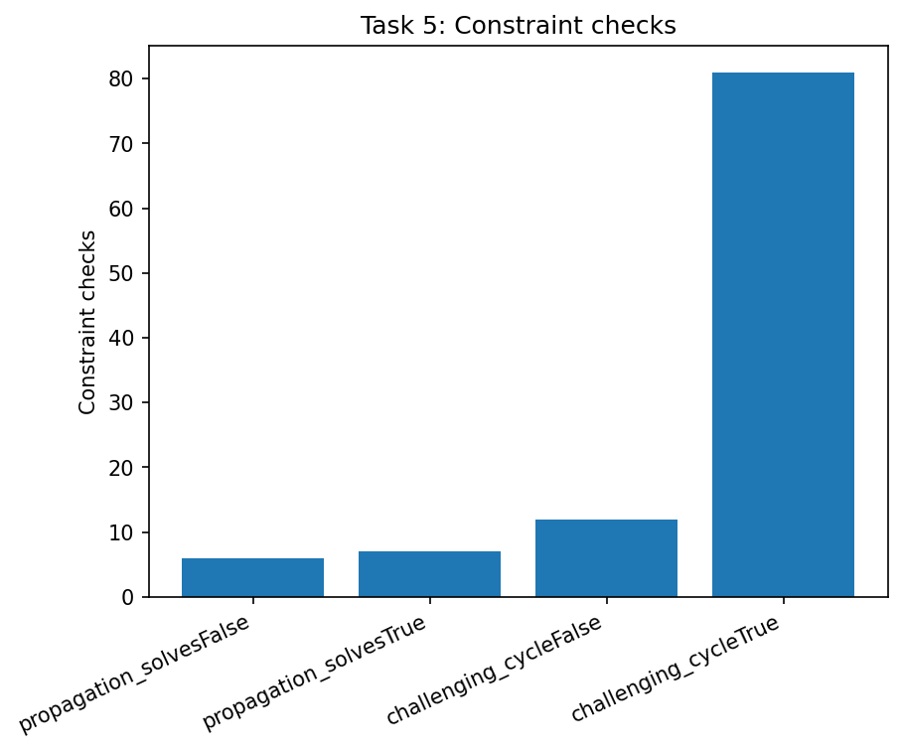
Figure 4. Constraint checks for the test instances.
Correctness argument: if a value has no compatible value in a neighbouring variable's current domain, that value cannot participate in any complete assignment satisfying that binary constraint. Removing it therefore cannot remove a valid solution. Repeating this reasoning preserves all solutions. Propagation may not solve every CSP; backtracking is still required when multiple values remain.
Interpretation: compare the counters rather than relying only on elapsed time. Constraint propagation adds checks and queue work, but it can reduce the search tree by removing unsupported choices early. Its benefit depends on how strongly the constraints restrict the domains.

Task 6 – Exhaustive Search, Local Search and Combinatorial Growth

Prediction before experiment
Fixing one customer as the starting depot leaves (n−1)! possible visit orders for n customers. Therefore, each additional customer multiplies the candidate count by n. Exhaustive search guarantees the optimum but becomes expensive quickly. A 2-opt local search reverses portions of a tour to reduce its length; it is faster on larger instances but may stop at a local optimum.

Algorithm and correctness check
A tour is represented as an ordered list of customer indices, with index 0 as the depot. Exhaustive search enumerates every permutation of the remaining customers and retains the least-cost tour. The small five-customer case can be independently checked by enumerating all 24 tours. The local alternative uses 2-opt and 20 fixed random seeds per size.

Expected behaviour
Candidate tours should equal (n−1)!. The local search should return valid tours and may produce a small positive percentage gap from the exhaustive optimum. Its result can vary by starting seed.
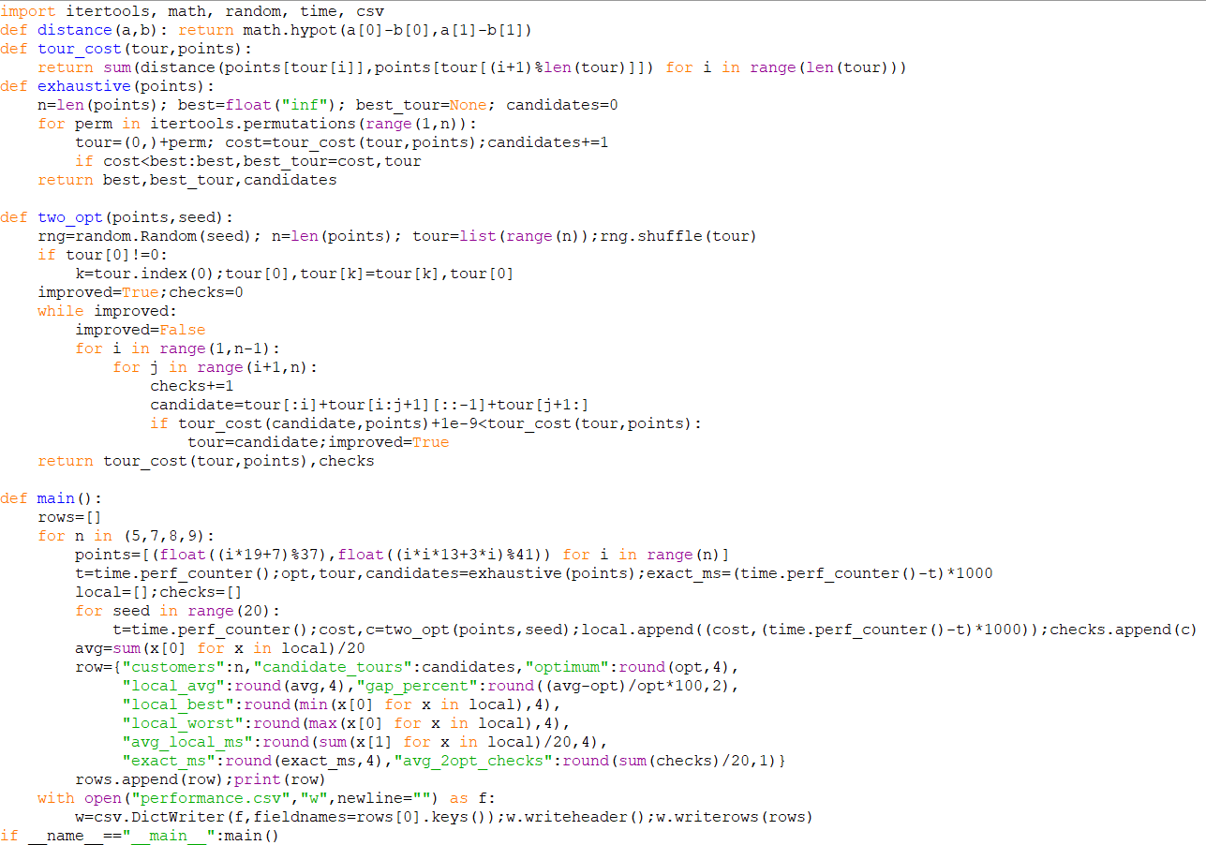

Actual output and performance

customers | candidate_tours | optimum | local_avg | gap_percent | local_best | local_worst | avg_local_ms | exact_ms | avg_2opt_checks
5 | 24 | 68.6587 | 68.6587 | 0.0 | 68.6587 | 68.6587 | 0.048 | 0.0615 | 14.4
7 | 720 | 94.0703 | 94.0703 | 0.0 | 94.0703 | 94.0703 | 0.1296 | 1.1442 | 36.0
8 | 5040 | 97.3009 | 97.3009 | 0.0 | 97.3009 | 97.3009 | 0.222 | 9.9626 | 57.8
9 | 40320 | 98.8756 | 98.8756 | 0.0 | 98.8756 | 98.8756 | 0.35 | 80.073 | 82.6
Table 6. Exhaustive and 2-opt results over 20 seeded runs.
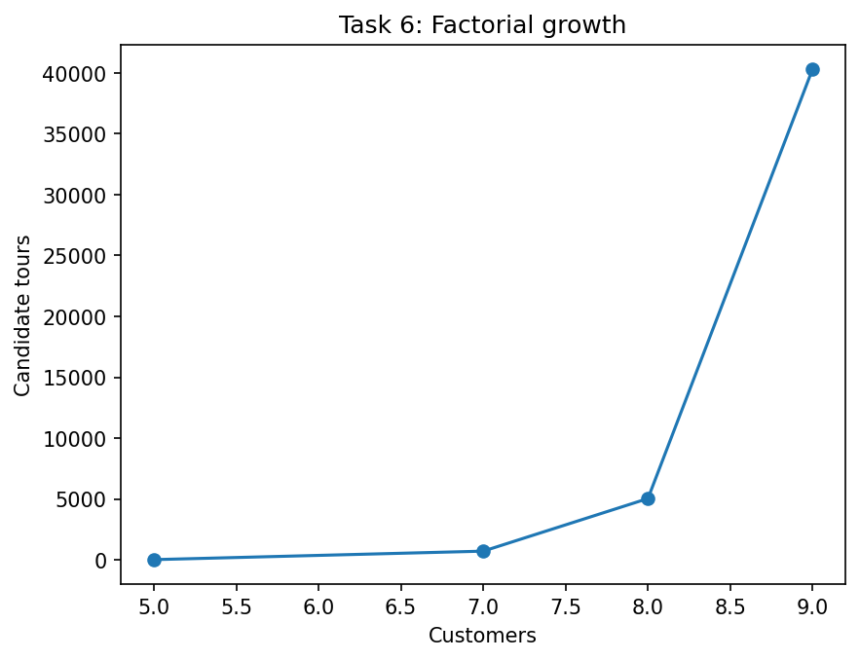
Figure 5. Factorial growth in candidate tours.
Interpretation and deployment decision: factorial growth explains why adding a few customers can cause a dramatic increase in work. Local search can stop at a local minimum or plateau because no single 2-opt move improves the current tour, even though a better tour exists elsewhere. For a fixed response-time budget, use exhaustive search only for small n after measuring the target machine. Switch to local search when the factorial candidate count exceeds the available computation budget; retain exhaustive search when a proof of optimality is essential and n is small.

Task 7 – Diagnose, Redesign and Validate

A. Diagnose the bottleneck
Task 6 shows that exhaustive tour enumeration evaluates (n−1)! complete tours. The dominant cost is repeatedly evaluating complete candidate tours. The number of permutations grows factorially, so the work rises rapidly as customers are added.

B. Design objective
Objective: preserve the exact optimal tour while reducing the number of search nodes evaluated compared with exhaustive enumeration on the same coordinate sets.

C. Revised strategy
The redesign uses a branch-and-bound search. A nearest-neighbour tour first supplies an upper bound (a complete feasible tour). For a partial route, a lower bound is calculated as: cost already travelled + minimum spanning tree cost of unvisited customers + cheapest connection from the current endpoint to an unvisited customer + cheapest return connection to the depot. If this lower bound is not better than the current best tour, the entire branch is discarded. The lower bound is admissible because any completion must connect all remaining customers and return to the depot.
Trade-off: calculating the minimum spanning tree bound costs extra computation, but it can avoid exploring many complete permutations. The strategy remains exact if the bound never overestimates the cheapest possible completion.

D. Prediction before implementation
Prediction: branch-and-bound should return the same optimal tour cost as exhaustive search while visiting fewer search nodes on these instances. It will use additional work to calculate bounds.
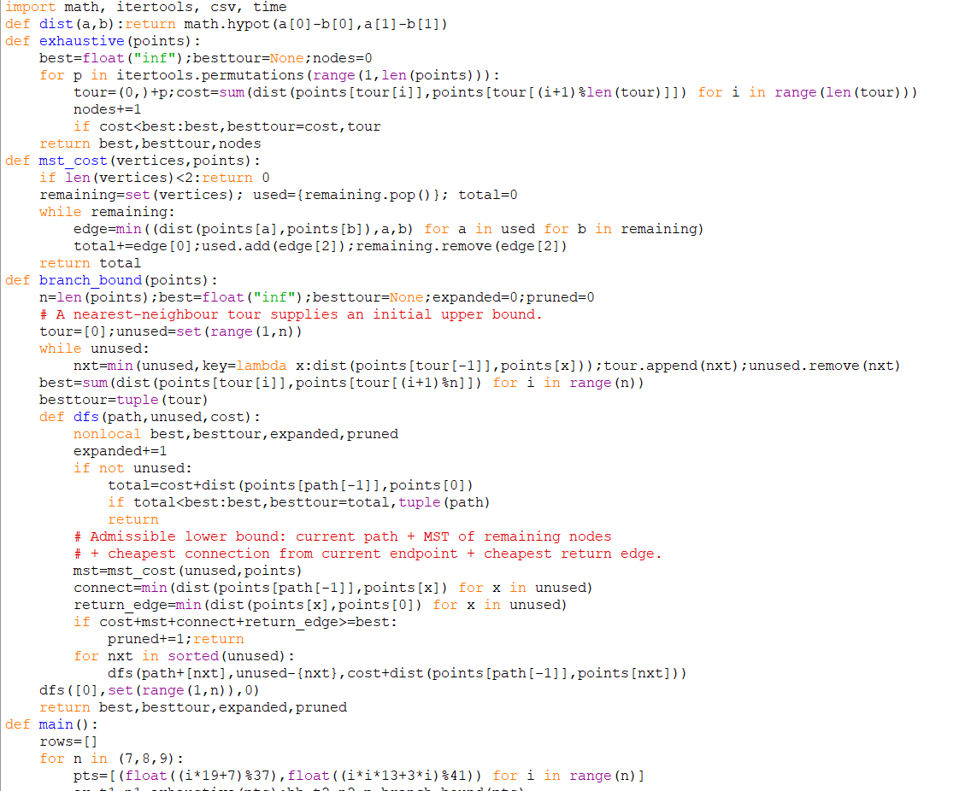
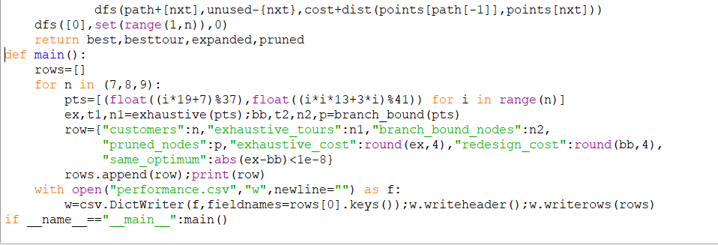

E. Implementation and validation
customers | exhaustive_tours | branch_bound_nodes | pruned_nodes | exhaustive_cost | redesign_cost | same_optimum
7 | 720 | 145 | 92 | 94.0703 | 94.0703 | True
8 | 5040 | 307 | 205 | 97.3009 | 97.3009 | True
9 | 40320 | 464 | 332 | 98.8756 | 98.8756 | True
Table 7. Original exhaustive search compared with branch-and-bound.
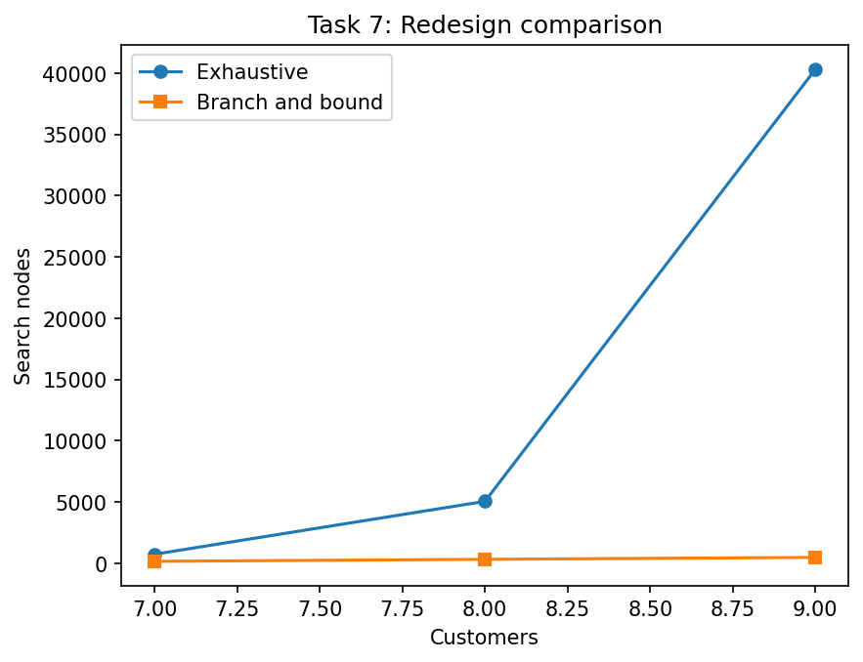
Figure 6. Search-node comparison for the redesign.

F. Final defence
The redesign achieves its correctness objective when the reported costs match exhaustive search. The node-count comparison indicates whether the lower bound prunes work on the tested instances. Its new cost is the repeated calculation of a minimum spanning tree lower bound. For very small instances, plain exhaustive enumeration may be simpler and faster because bound calculation has overhead. For larger instances, branch-and-bound is preferable when its pruning benefit exceeds that overhead.

Conclusion
The experiments demonstrate that algorithm choice depends on problem structure and operating conditions. A* combines path cost with an admissible heuristic; online search is useful when the map is unknown but repeated exploration is costly; alpha-beta depends strongly on move ordering; minimax grows exponentially with depth; constraint propagation can reduce CSP search; exhaustive TSP enumeration grows factorially; and branch-and-bound can reduce explored work while retaining an exact result.

